SHACMAN
X3000 6×4 CNG Tractor Truck Main Specifications
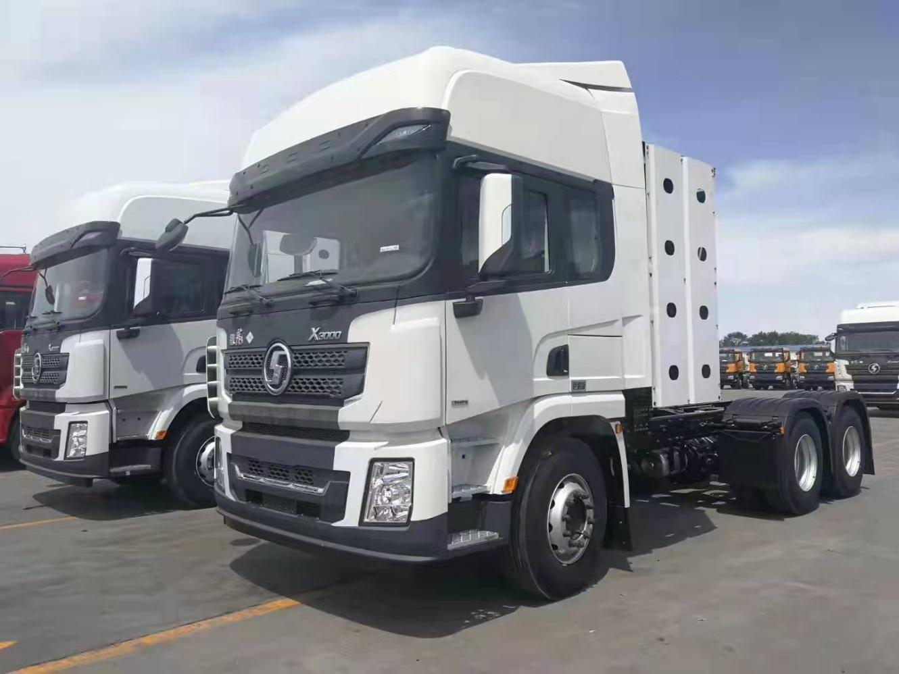
picture for reference only）
Driving type |  | 6×4
Weight | Curb mass (kg) | 12000
 | GCW (kg） | 949000
Dimensions | L×W×H (mm) | 7625×2490×3250
 | Wheel base (mm) | 3975+1400
 | Front/overhang (mm) | 1525/725
Performance | Max. speed ( km/h) | 105 km/h
Engine | Brand | WEICHAI POWER
 | Model | WP13NG430E52
 | Power (KW/HP) | 316/430
 | Max. torque (N. m)/rpm | 2000/1100-1400
 | Displacement (L) | 12.54L
 | Emission standard | Euro 5
Air filter | FLEETGAURD
Clutch | Type | Single plate, diaphragm spring
 | Diameter (mm) | φ-430 Made in China
 | Action | Mechanical type, hydraulic and pneumatic operation
Transmission | Brand | FAST
 | Model | 12JSD200TA-B+QH70
 | Control type | Manual
 | Gear shift | 12-forward and 2-reverse speeds
Axles | Brand | HANDE
 | Front axle | 7500kg×1， MAN tech turning axle
 | Rear axle | 16000kg×2，MAN tech Driving axle ,double reduction driving axle with wheel-inner differential and differential lock
 | Ratio | 4.769
Brakes | Type | Drum Brake
 | Service brake | With dual-circuit compressed air brake
 | Park brake | Power spring brake acting on rear wheel
 | Auxiliary brake | Four-channel ABS
 | Retarder | FHB400
Steering | Type | Integral circuiting ball power steering
Suspension | Front suspension | Multi-plate leaf spring front suspension
 | Rear suspension | Multi-plate leaf spring rear suspension
Tires | Type(standard) | 12R22.5× (10+1 spare tire Triangle brand)
Electric system | Battery：165AH×2，24V, maintenance-free battery
Cylinder | Capacity (L) | 8×212 L steel （8*212L is bigger than 8*150+4*80）
Cab | Type | SHACMAN X3000 high roof CAB with Air shroud
 | Cab devices | Auto AC/Two sleeper /Electric windows lifter/Air suspension main seat with safety belts/Four points air suspension of cab/Electric cab reversal/Radio with MP3/2 kg fire extinguisher/Electrostatic towing×1/Multi-function steering wheel with automatic cruise function/Central lock (dual remote control)/Electric heating rearview mirror/Parking wedge block

